Add Translate

Contents

1. Introduction 2

2. Add a translation 2

# 1. Introduction

Translation is necessary for changing the language by clicking the desired language

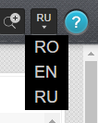

* Rename the names to the necessary in your project

# 2. Add a translation

To add a translation it is necessary to write the following part of code in the place where will be shown the text:

@Html.Raw(MedProject.Helpers.T.Str("Farmacy", "DashBoard"))

«Farmacy» - represents the key word by which is searched the translate

«DashBoard» - represents the table in which is stored the translate

The translate depends on the extension after the name of the table (.en, .ro, .ru)

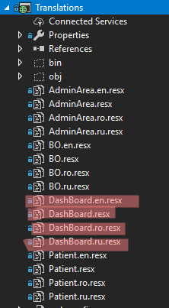

The first column is for the key word, and the second is for the translate:

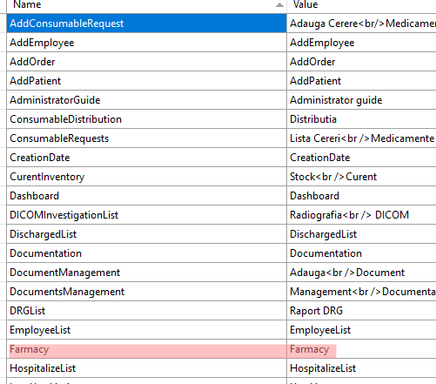

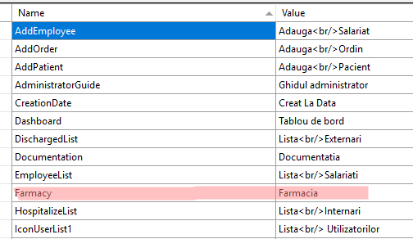

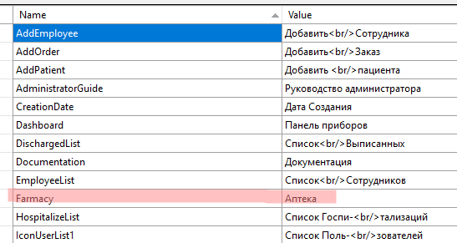

Here is the result:

